# Providing Symbols for GC Wizard

First of all, please check if the symbols are under a special license or free to use. If the symbols are not free, we are not allowed to use them and so you can stop here with your work, even if it is sad.

# TTF 2 SVG

<https://everythingfonts.com/ttf-to-svg>

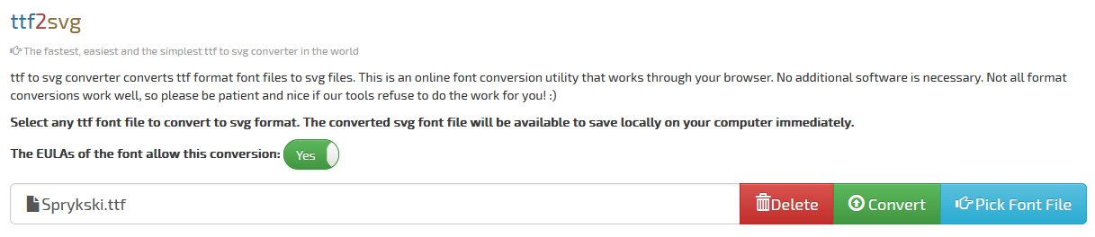

1. Pick Font File
2. Accept EULA
3. Convert and save the ZIP file
4. Extract the included SVG file

# SVG 2 PNG

<https://icomoon.io/app/#/select>

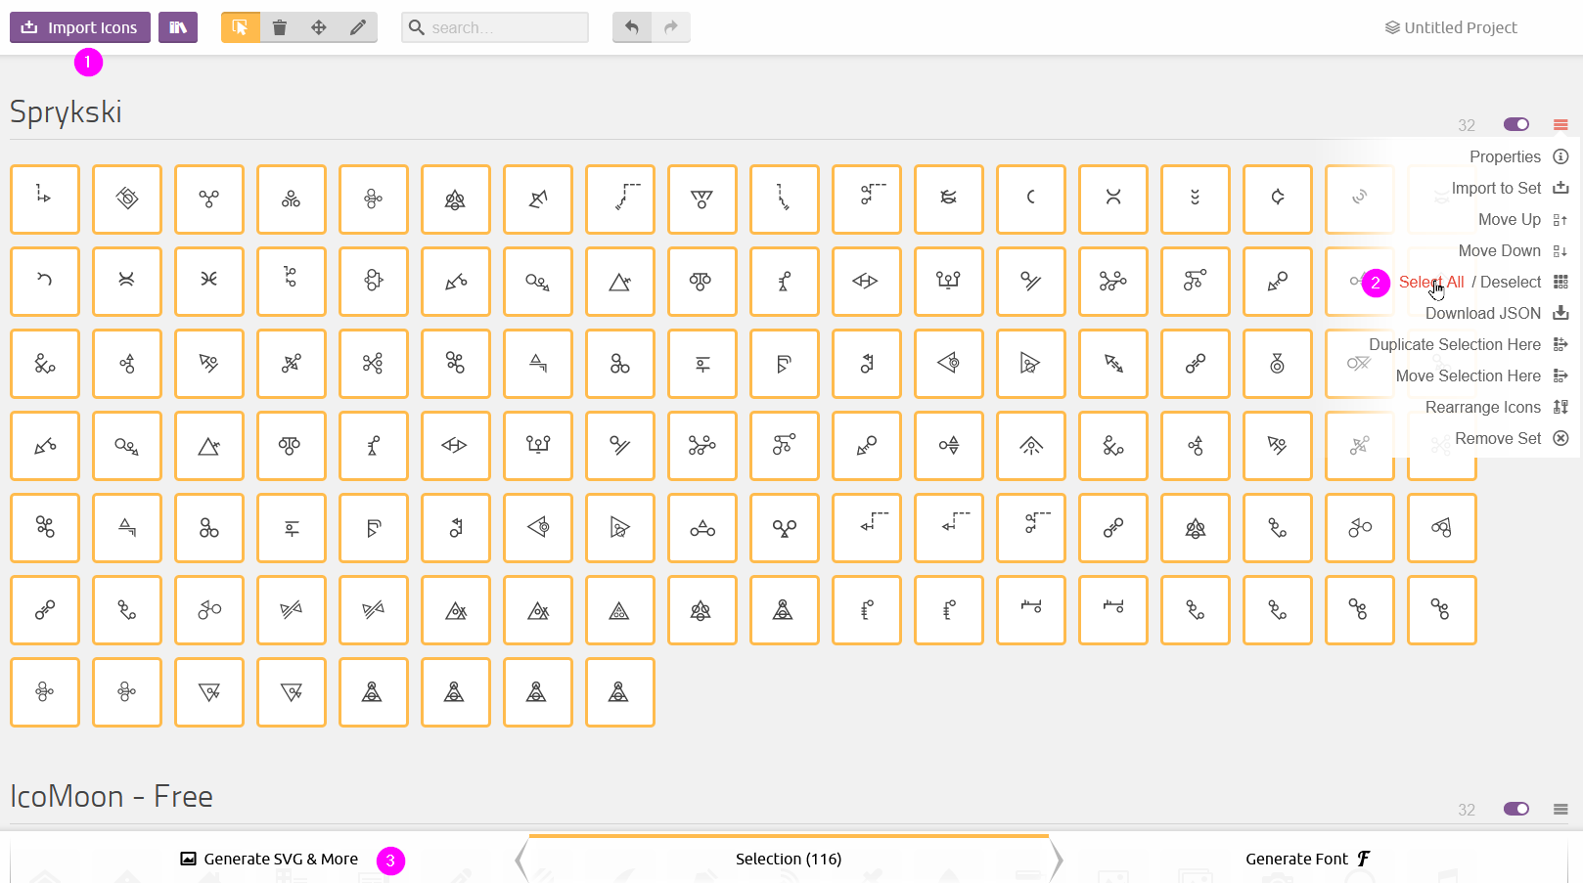

1. Import Icons and choose your extracted SVG file
2. Open the burger menu on the upper right side and click onto „Select all“
3. Change the card at the bottom to „Generate SVG & More“

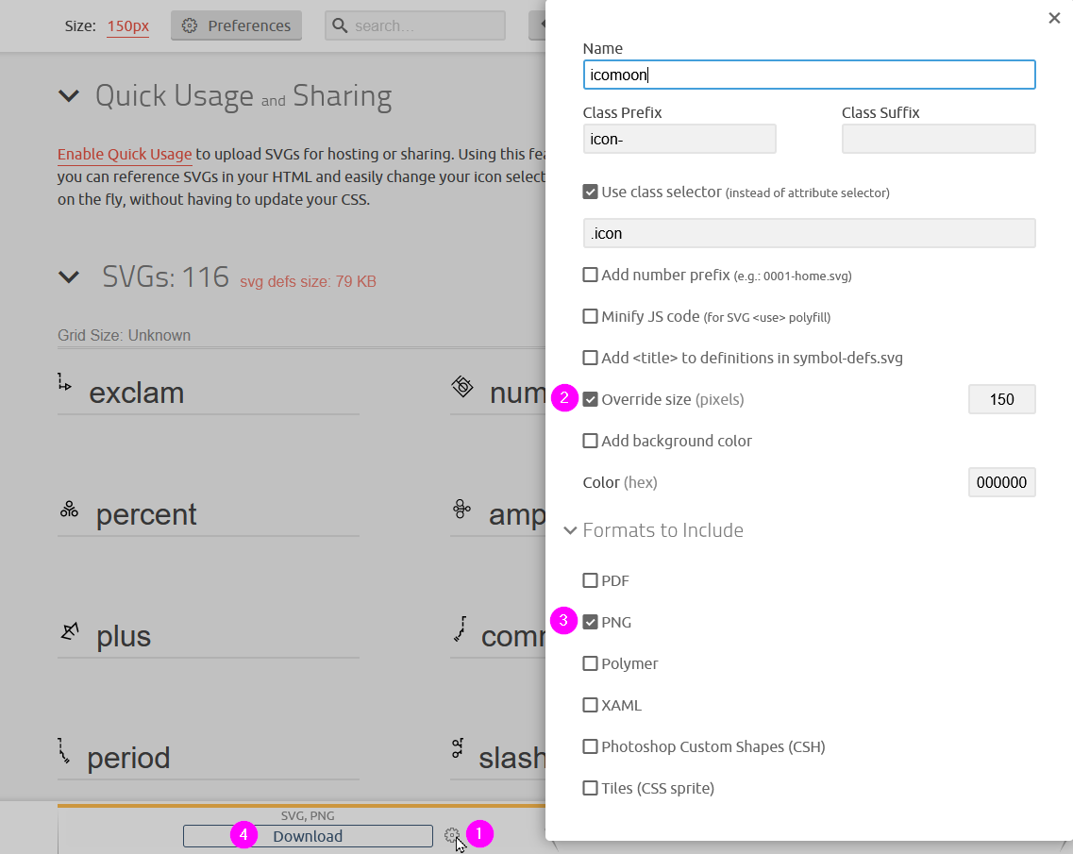

1. Rename the symbols to valid entries
2. Click onto the appearing gear on the bottom or in the top area
3. Activate „Override size“ and type in „150“
4. Choose the format „PNG“
5. Click Download and save the ZIP file

# Rename and cleanup files

1. Extract the ZIP file with WINRAR and answer the question for duplicates with „Rename all“
2. Rename the files in the folder PNG to valid names like a 🡪 _a; A(1) 🡪 A  
   and clean from unnecessary files

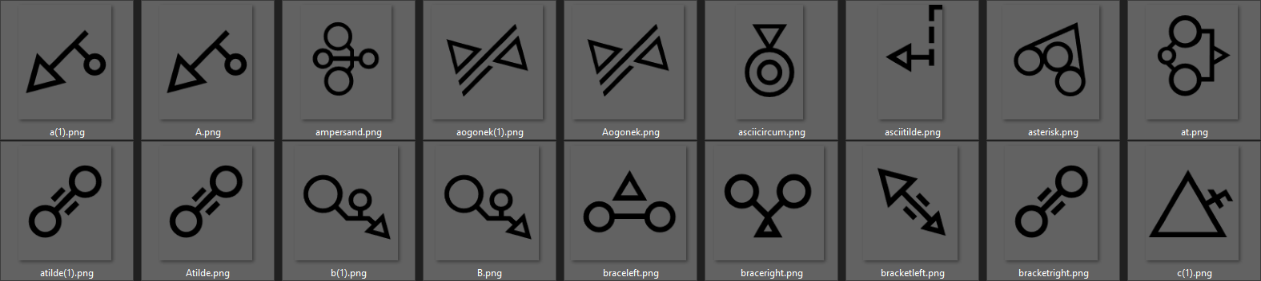

# Optimize file size and colour depth

Use Irfanview from <https://www.irfanview.com/64bit.htm>

Press “b” on your keyboard for “Batch Conversion/rename”

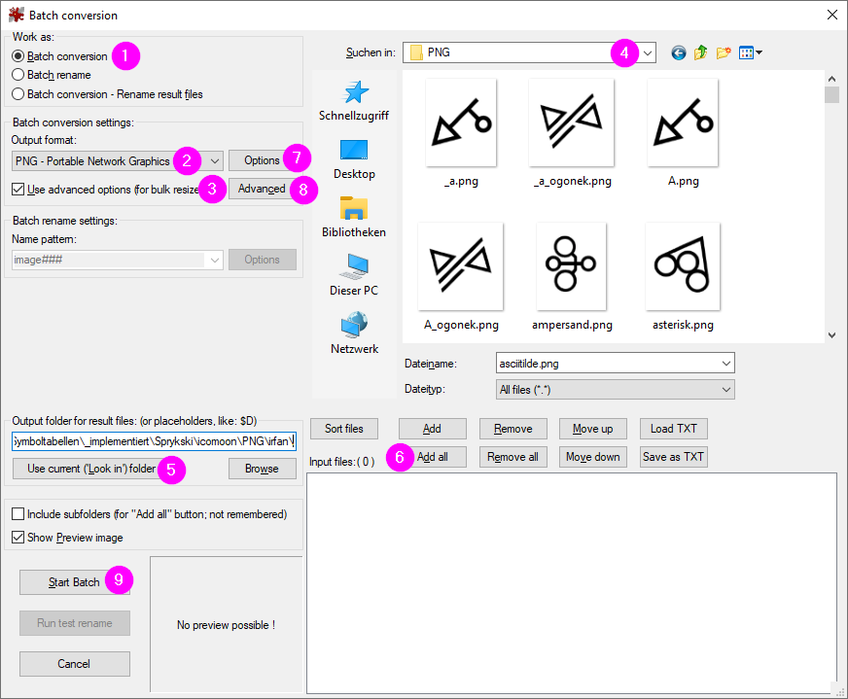

1. Choose “Batch Conversion”
2. Choose Output format “PNG”
3. Activate “Use advanced options”
4. Choose the folder with your renamed and cleaned PNG files
5. Click “Use current (‘Look in’) folder to overtake the folder also as output and add “Irfan\” at the end
6. Add all files
7. If not done before, set the correct “Options”  
   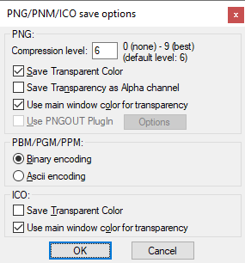
8. If not done before, set the correct “Advanced” setting  
   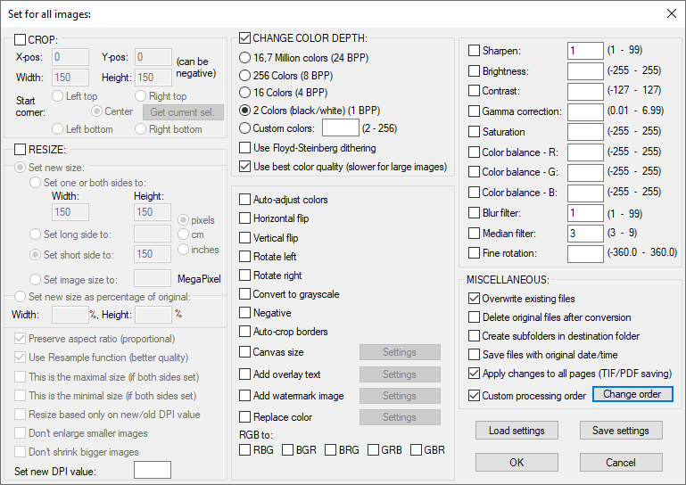
9. Start batch

# Provide symbols

1. Add all symbol files to a ZIP file
2. Choose a representative symbol as logo.png
3. Provide further information:
   1. Title of the symbol table
   2. Description
   3. Possible search strings language independent (like Names)
   4. Possible search strings EN (also like how the symbols look like e.g. dots, circles
   5. Source - Where did you get the symbols from?
   6. Under which license are the symbols?
4. Upload everything e.g. to github